**To Retrieve the Student Information:**

1. **Retrieve student details**

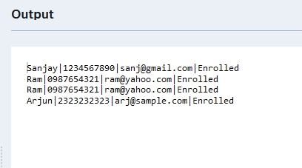

1. **Retrieve list of courses for a specific student**



1. **Retrieve course information including instructor**

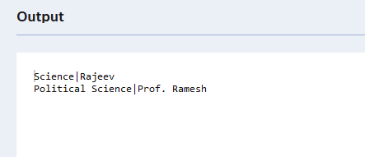

1. **Retrieve course information for a specific course**

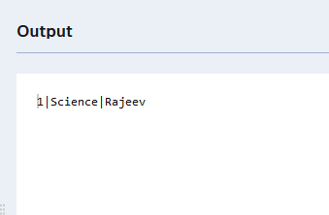

1. **Retrieve course information for multiple courses**

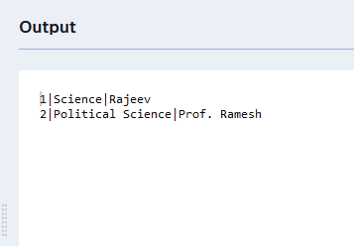

**Reporting And Analytics:**

1. No of Students enrolled in each course

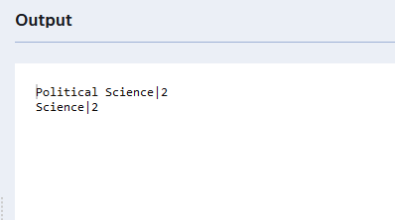

1. List of Students Enrolled in Specific course



1. Count of Students enrolled for each instructor

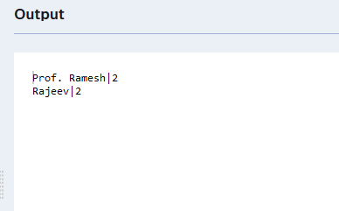

1. List of Students enrolled in multiple courses



5 Course with highest student enrollment

